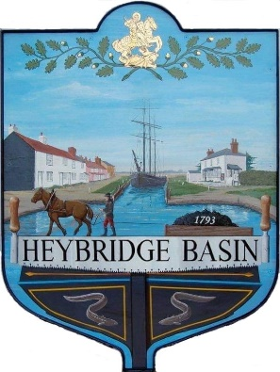
HEYBRIDGE BASIN PARISH COUNCIL
Donation Policy

- Objective

Heybridge Basin Parish Council occasionally receive requests from charities, voluntary and community organisations and sometimes individuals and other not-for-profit organisations for financial support. These include both locally based organisations and local branches of national organisations.

The Parish Council wishes to support activities and causes which benefit the parish of Heybridge Basin.

- Eligibility

Any donation made by the Parish Council must directly benefit some or all the parishioners of Heybridge Basin but cannot be for an individual (unless the individual is carrying out a service which benefits parishioners. A Community First Responder (an NHS trained volunteer) whose role is to be the first on the scene as the result of an emergency call within a designated area (the Parish) to provide immediate life-saving support and who is required to raise funding to contribute towards the cost of the necessary equipment. It is clear that any donation made by the local Council will directly benefit recipients of the service and it is, therefore, our opinion that the donation can legally be given, and payment can be made to the individual.)

The following criteria must be met:

- The purpose for which the donation is made must be in the interest of the Heybridge Basin.

- Requests for Donations are only applicable to the financial year in which the request is made, and a new request form needs to be submitted each financial year.

- All applications will be considered on their merits. The Council will not give donations towards running costs or salaries.

- Applications for donations in kind in the form of reduced price or free use of the Parish Council facilities will be considered.

- Conditions
- The donation shall be used only for the stated purpose otherwise the monies shall be returned to the Council, except where the Council’s prior written consent has been given for the funds to be used for another purpose.

- The Council may request that applicants provide written feedback explaining how the donation has benefited their group/organisation. If feedback is required, this will be communicated in the decision letter.

- Where equipment is gifted to an organisation, the Parish Council requires that it be insured and maintained at the expense of the user.

- The Parish Council will consider any previous grant made to an organisation or group when considering a new application.

- The Parish Council will only consider requests if there are budgeted resources available.

- The Parish Council reserve the right to amend the amount requested or to decline the application without reason. The Council decision is final.

- An acknowledgement on receipt of the donation is required.
- The Council reserves the right to request repayment of any donation where an applicant does not comply with these conditions.

- Application process

- Applications should be made in writing by completing the Donation Funding Application form.
- Applications are accepted at any time of the year, but previous knowledge of on-going annual donation requests should be made by the setting of the annual precept.
- Applicants are usually informed within two weeks of the meeting.

- Promotion

The Parish Council will ask for recognition from successful applicants in the form of the promotion of the Parish Council in the organisation’s newsletter, press release or social media updates.
The Parish Council will also recognize successful applicants in its own reports to parishioners.

- Monitoring and review

This policy will be reviewed annually.

Reviewed and approved: | Minute:
16th May 2023 | 23/14 c

